Cañete, Alenne Jasper

Dodog, Bai Nhor

Quije, Fritz Evar

**Questionnaire or Survey**

1. In general, what do you do currently to put up your goods for sale?
2. What are the reports you need for the business?
3. What kind of goods do you put up for sale?
4. Do you ever encounter difficulties in putting up the goods in person at the market?
5. Do you ever encounter difficulties in storing and monitoring sales reports in a spreadsheet?

**Context–Level Diagram**

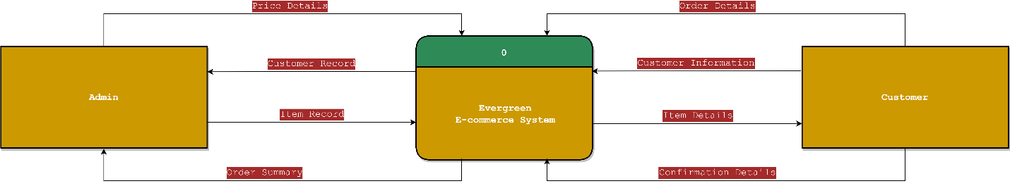

**Level 0 Diagram**

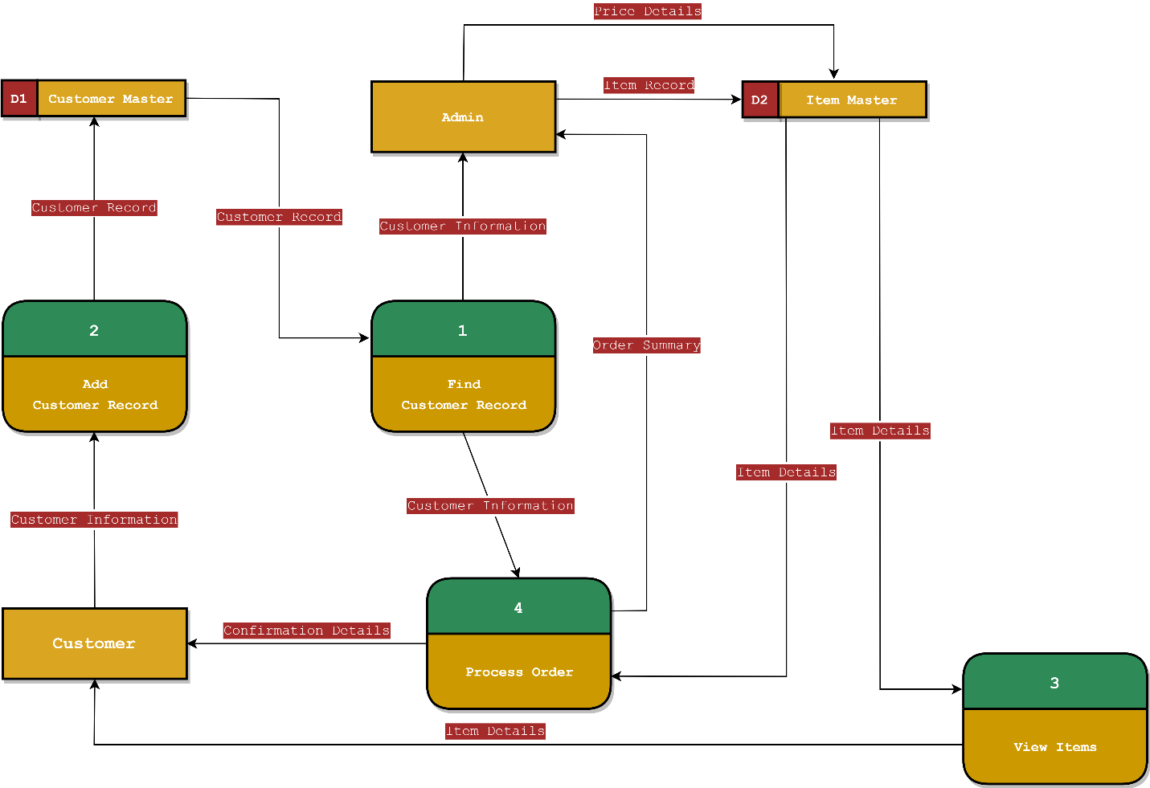

**Use Case Diagram**

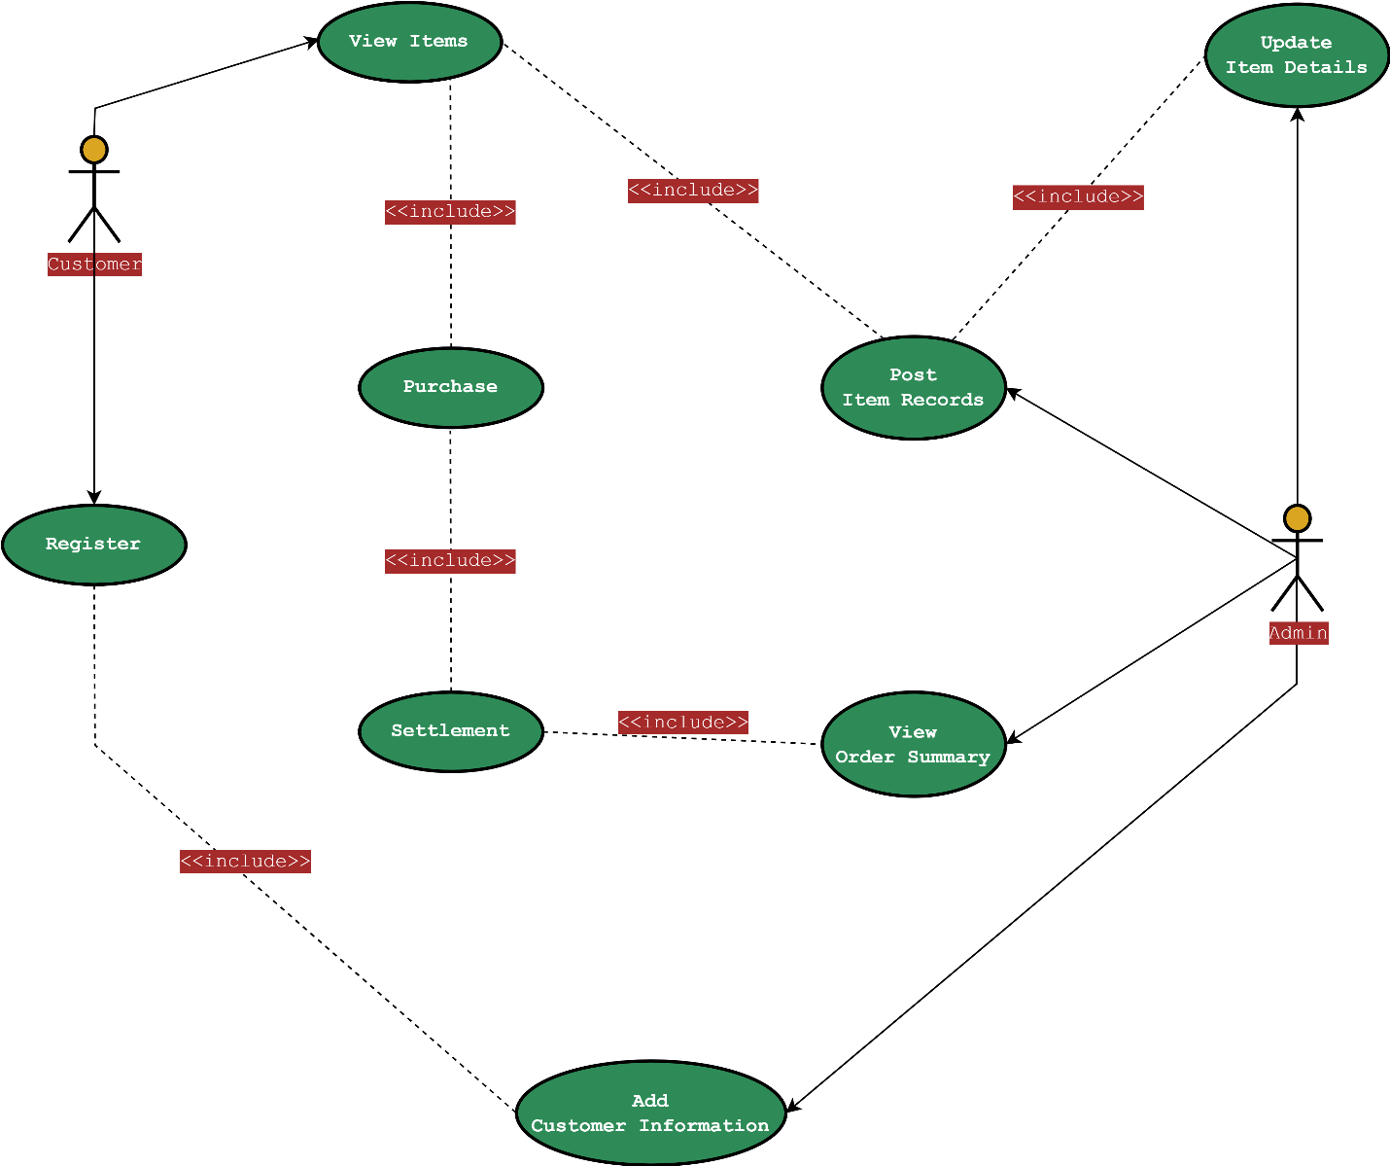

**Activity Diagram (Register)**

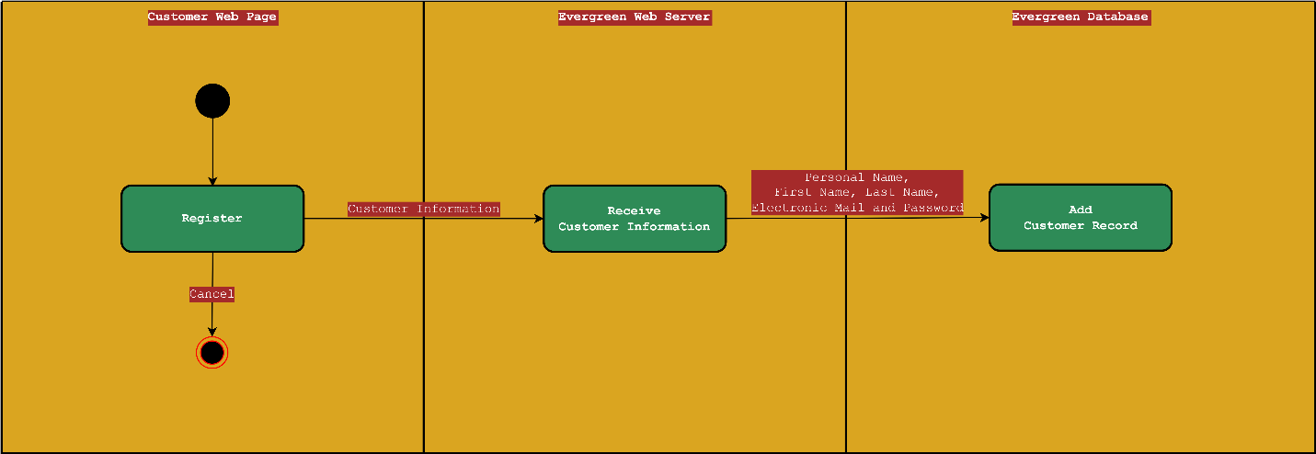

**Activity Diagram (View Items)**

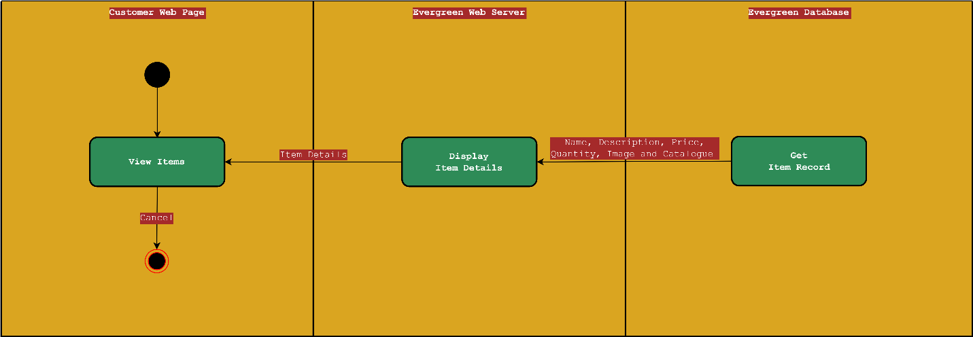

**Activity Diagram (Purchase Items)**

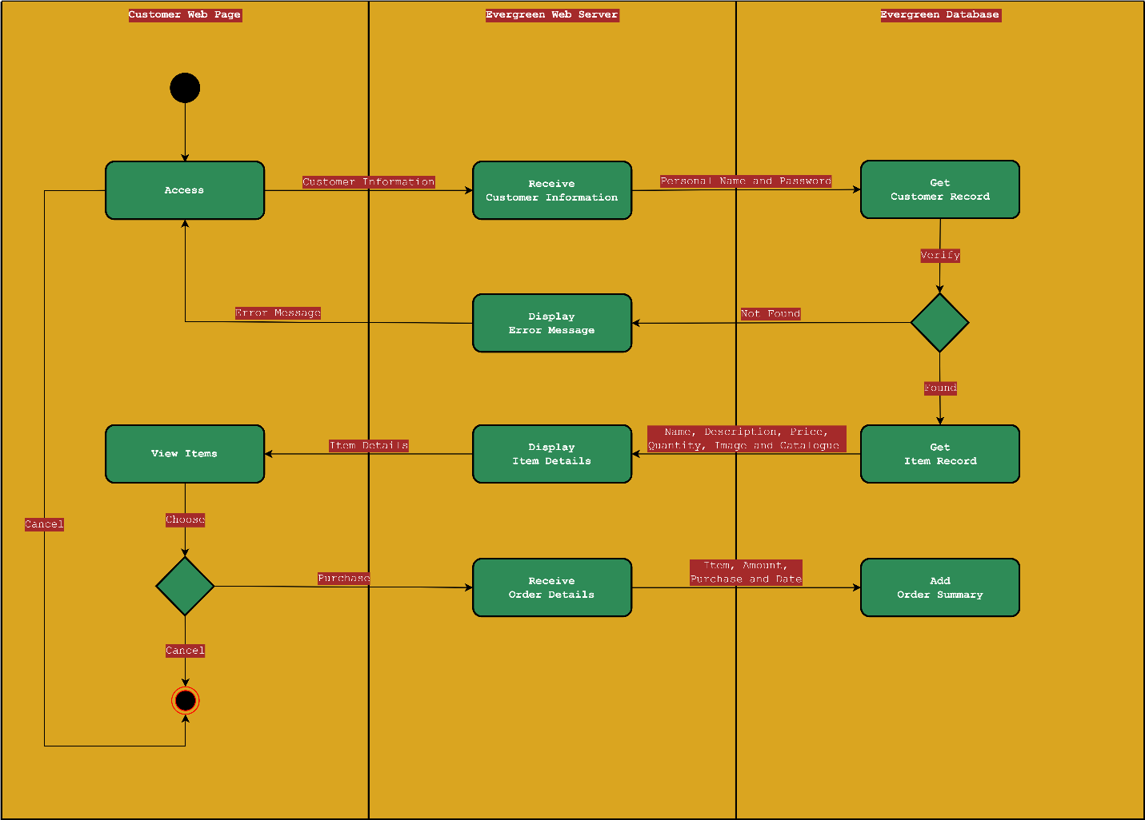

**Activity Diagram (Settlement)**

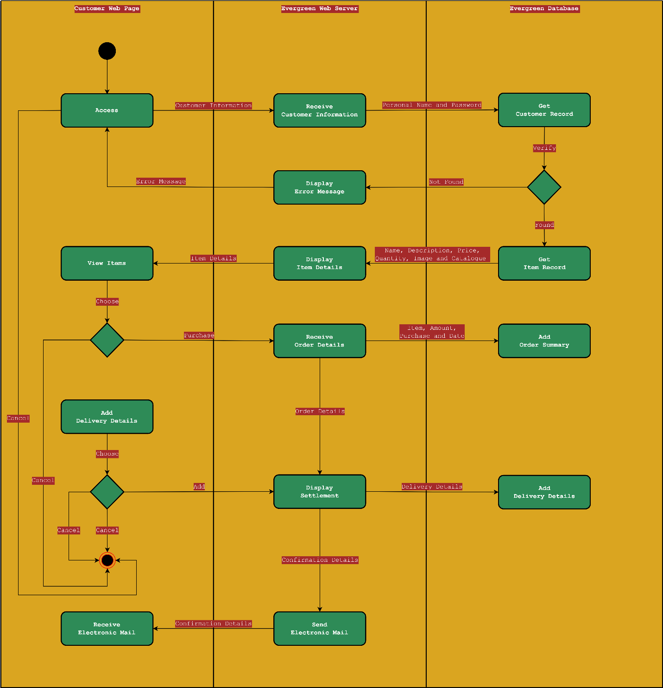

**Activity Diagram (View Customer Confirmation)**

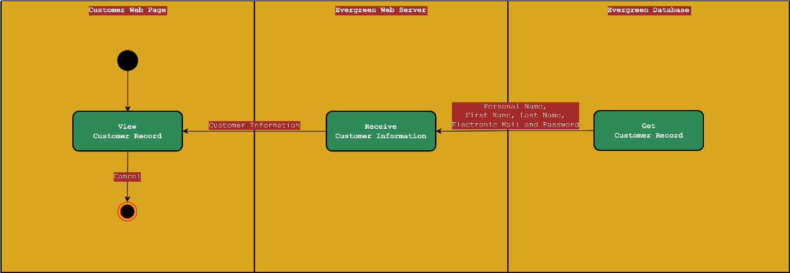

**Activity Diagram (Post Item Details)**

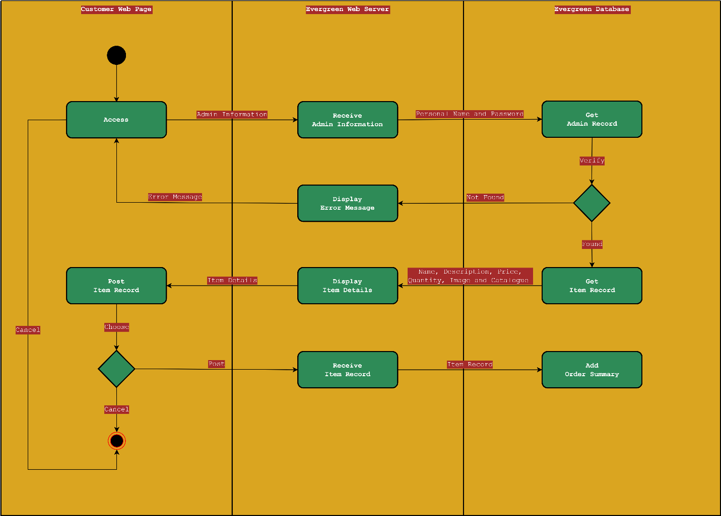

**Activity Diagram (Update Item Details)**

